**UNIT-II MINEROLOGY**

**Mineral**: a naturally occurring crystalline, inorganic, homogenous solid with a chemical  
composition that is either fixed or varies within certain fixed limits, and a characteristic internal  
structure manifested in its exterior form and physical properties.

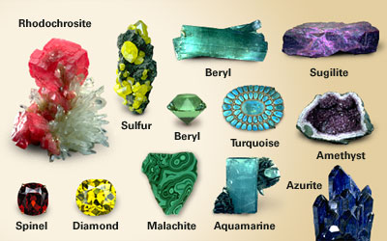  
**Physical Properties of Minerals**

**Colour**  
• on a fresh surface in reflected light

• The colour or lack of colour may be diagnostic

• Be careful- it can vary due to small differences in chemical composition!

• Small impurities may also change the colour

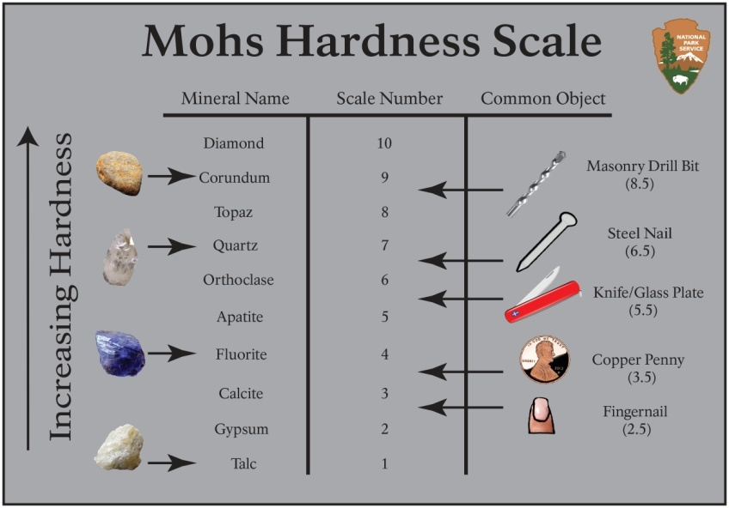  
**Hardness** is the resistance to abrasion (scratchability)

• Determined by either trying to scratch a mineral of unknown hardness with a substance of known hardness or by using the unknown mineral to scratch a substance of known hardness.

• Mohs Scale of hardness: 10 minerals arranged by hardness

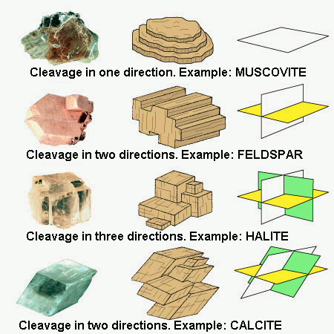**Cleavage**  
• Defined as the tendency of a mineral to break along definite planes of weakness that exist in the internal structure

• It is almost impossible to break some minerals in such a way that cleavage planes do not develop. Calcite and pyrite are great examples

• A well defined cleavage plane will reflect light off of it’s very smooth surface

• Look for repetitions in the breaks of the crystal

• Do not be confused with mineral growth faces, such as quartz!

• If there is no cleavage, there is fracture. ex: conchoidal fracture patterns in obsidian or the  
fibrous fracture of asbestos.

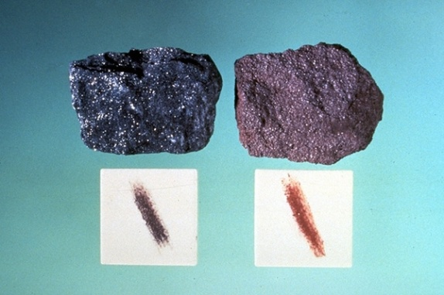**Streak**   
• The colour of a mineral powder, produced from rubbing the mineral against a porcelain streak plate, either black or white

• Some minerals have a very unique streak colour ex: hematite(cherry red)

• In general, metallic minerals have a unique streak colour

• Limitation: the streak plate hardness is ~7

**Tenacity** • An index of a mineral’s resistance to be broken…or bent..

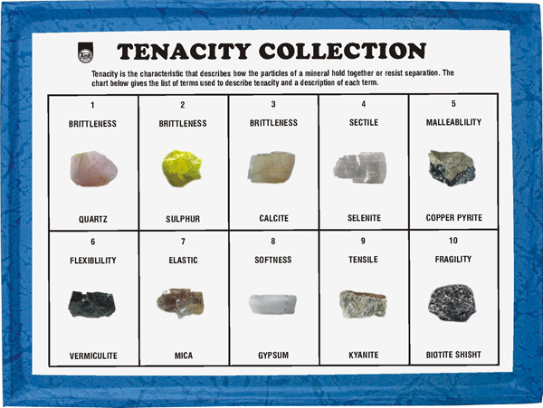• Many terms are used to describe tenacity, some examples in your lab manual are brittle, elastic, flexible

**Diaphaneity** • The ability of a mineral to transmit light

• Transparent, translucent, opaque

• Limitation: some minerals change properties with differing thicknesses..

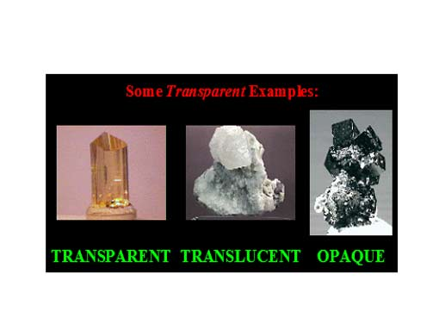

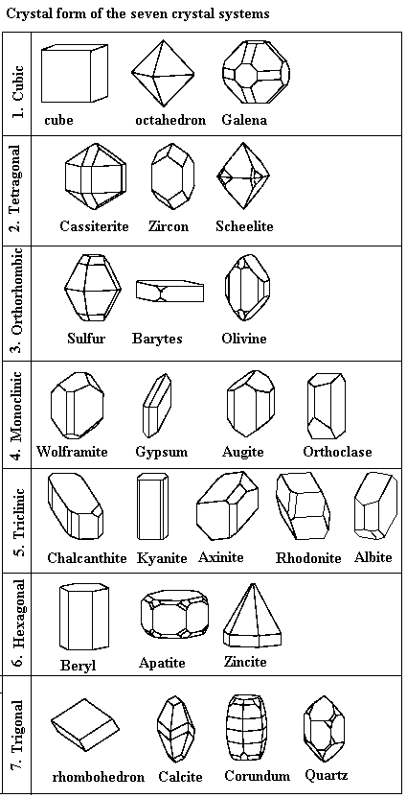**Crystal Form**

• The assemblage of crystal faces that constitute the exterior surface of the crystal

• Crystal Symmetry is the geometric relationship between the crystal faces

• Opposite: Amorphous

• 7 crystal systems: Cubic (or isometric),trigonal, tetragonal, hexagonal, orthorhombic, monoclinic, triclinic.

**Other physical Properties**

• Magnetism Lodestone compasses

• Double refraction

• Taste (Rock Salt, NaCl)

• Odor (Sulfur, Sphalerite ZnS)

• Feel (talc is greasy,hornblende is rough)

• Chemical reaction with HCL

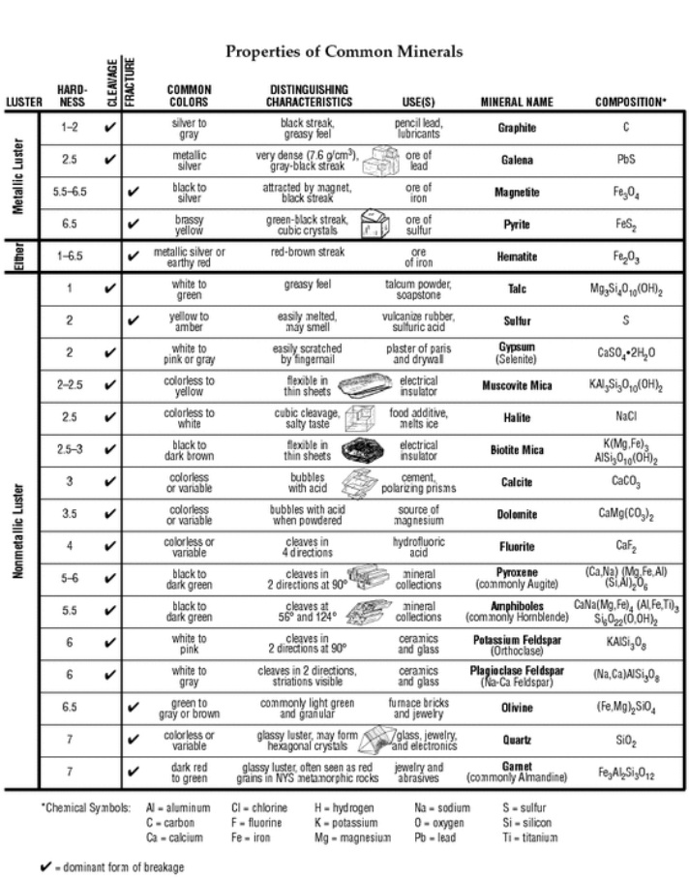**Identification of minerals by physical properties**

